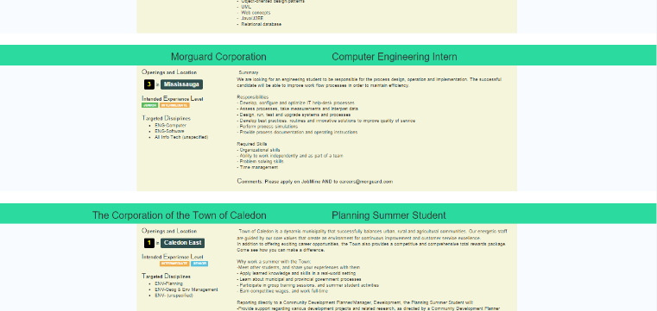Hi there! I ran into some issues when trying to set up the project (JobMine EZSearch) after forking it and if you haven’t used Python before, here are some steps for setting up. If you have, you can skip this document.

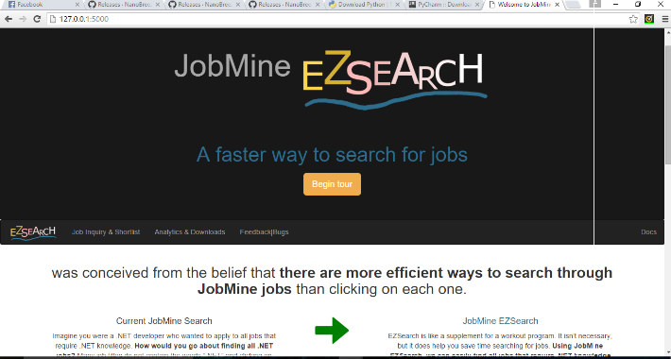

Hopefully, JobMine EZSearch can help you in your job search! One of the features that would likely help you is the “search by keywords”. Let’s say you’re looking to work with iOS, you can search for “iOS” in the keywords textbox and all jobs with “iOS” in the job summaries will appear.

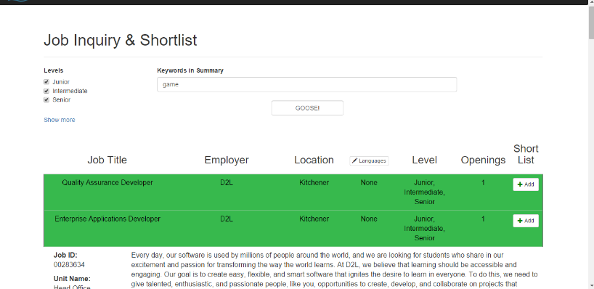**Step1:** Since JobMine EZSearch is a Python project, let’s download Python 3.5.1 from <https://www.python.org/downloads/>. On the first wizard path check the “Add Python 3.5 to PATH” checkbox and install Python.

**Step2:** After Python 3.5.1 has been installed, let’s download and install a Python IDE. Let’s use PyCharm Community:

<https://www.jetbrains.com/pycharm/download/#section=windows> . In most cases, you can accept the default setup options.

**Step3:** Open PyCharm and click on “Check out from Version Control” and select “Git”. In the new popup, enter <https://github.com/NanoBreeze/JobMine-EZSearch.git> into Git Repository URL

**Step 3.14:** You may need to install the requests library and bs4 library. To do this, type in Command Prompt: “pip install requests [ENTER]” and then “pip install bs4 [ENTER]”, “pip install flask [ENTER]”.

**Step 3.5:** Log into your [JobMine account](https://jobmine.ccol.uwaterloo.ca/psp/SS/?cmd=login) and make sure all the search filters Employer Name, Job Title, Discipline 1, Discipline 2, Discipline 3, Location, in Job Inquiry are empty. Please check Co-op Junior, Co-op Intermediate, and Co-op Senior. You may also set the Term to 1169. The press “Search”

**Step4:** Run setup.py from Pycharm’s Project window (on the left side of the screen) and remember to enter your username and password in the run console. These are stored in a local database and aren’t being snooped by mastermind. Your entered credentials stay only on your drive

**Step5:** After a job is downloaded, its summary will appear in the Run panel. It normally takes 5-15 mins to download all the jobs. After the jobs are downloaded (or a red error appears, don’t worry this is normal for now), double click on Main.py. Then run Main.py (click on Run->Run…->Main). If Main.py threw an “Error running Main:” exception, you can set the Interpreter by Run->Edit Configurations… and select Python 3.5.1.

**Step 6:** Click the blue link that appears in the Run window (eg, <http://127.0.0.1:5000>). This opens JobMine EZSearch. Any time you want to open JobMine EZSearch, run Main.py. You can navigate to “Job Inquiry & Shortlist” to search and shortlist jobs.

Hope this helps! If you run into any troubles, let me know.